PPSE e-Licensing Portal Instructions (RENEWAL)
1.0 - Log into portal. https://elicense.az.gov/  1.1 - Select ‘Login/ Create Your Account’ | 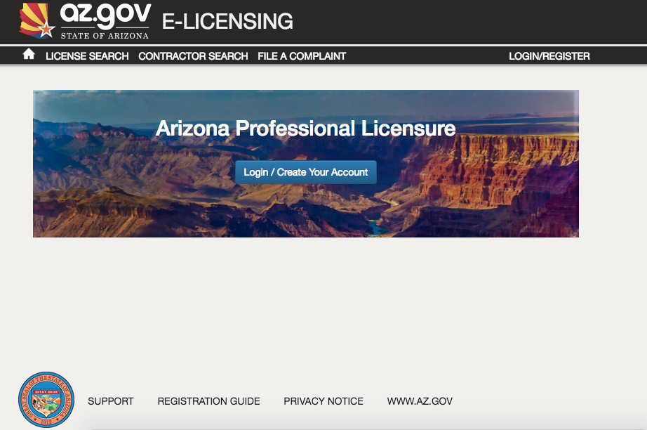
1.2 - Click ‘I Have a License’ | 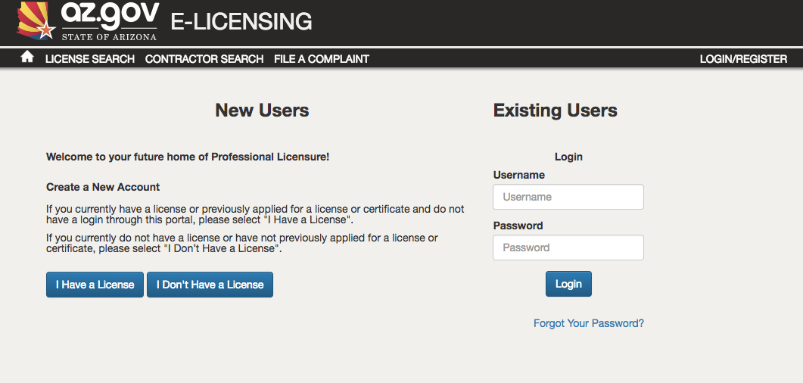
1.3 - Complete Self Registration  - Enter Security Code exactly as it appears: Contact the PPSE office for Code  - Create your password  - Click ‘Create new Account’ | 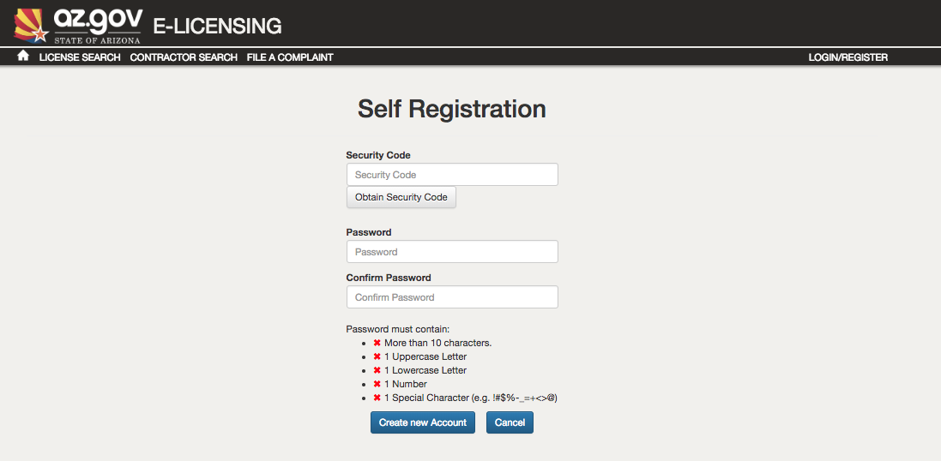
IF BUSINESS/LICENSE IS LISTED – SKIP TO 2.0  MAKE SURE YOU ARE IN YOUR DASHBOARD | 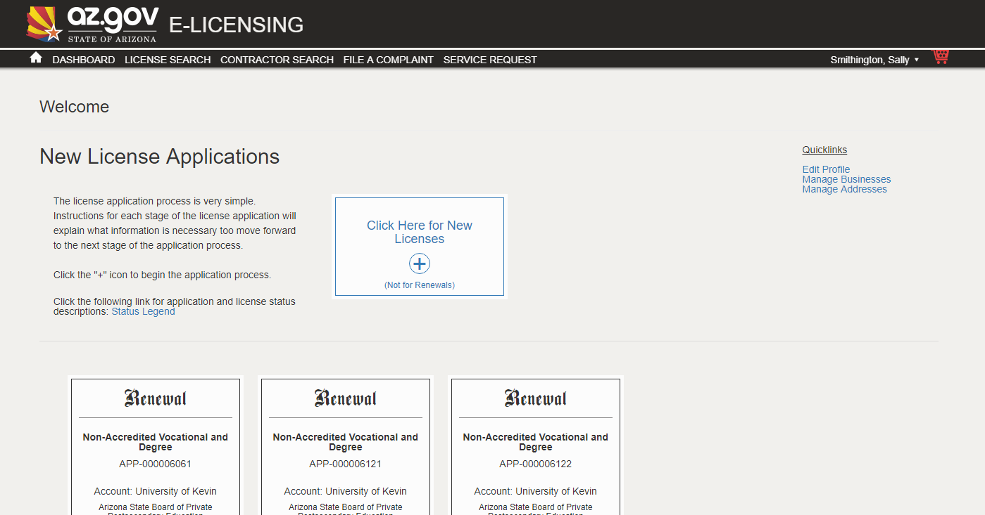
IF BUSINESS IS NOT LISTED  1.4 - : Click on ‘Manage Business’ under Quicklinks  - Click ‘Add existing business’  - Enter Security Code exactly as it appears: Contact the PPSE office for Code  - Your school will be added to your profile. | 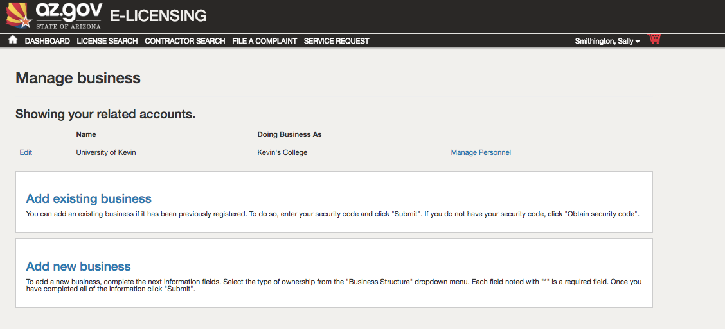
2.0 – You will now see your license(s). Locate “renew” button for license you are renewing. Click. | 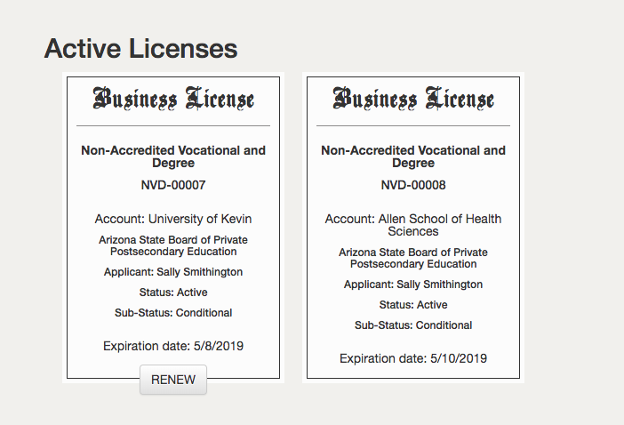
2.1 Board and license type should be pre-populated. Click Save and Continue. | 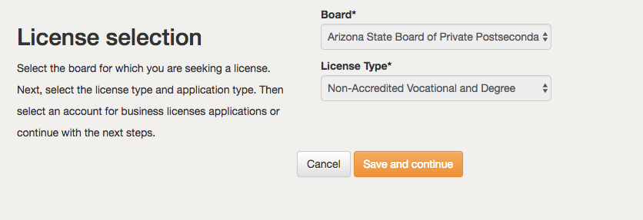
Complete Business Information
3.0 Review and complete the information on the page. | 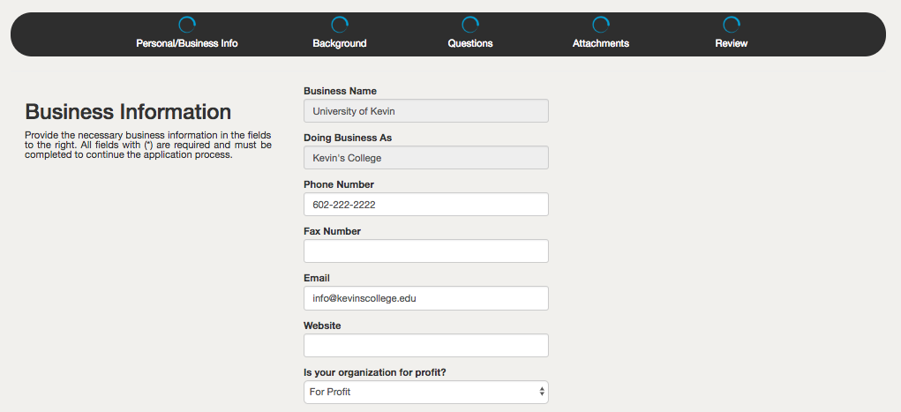
Select Address (must have physical and public address  Click Save and Continue | 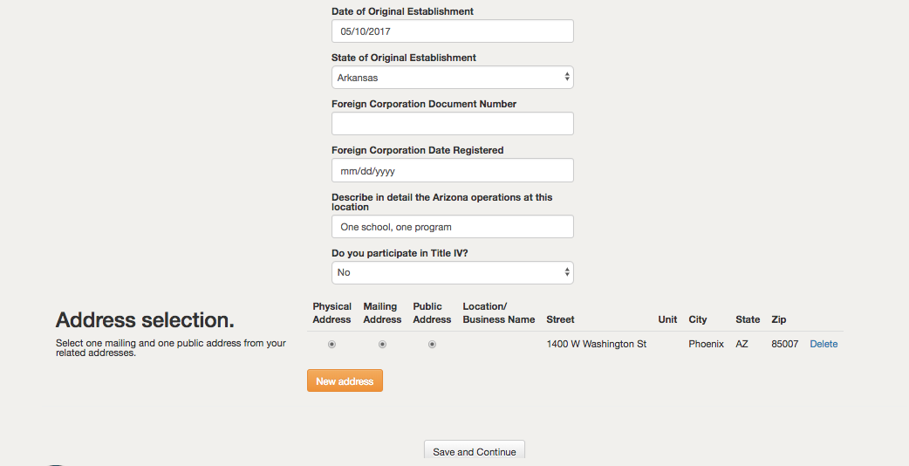
Academic Program Information
4.0 – Review/update your institutions programs. Click Manage Programs | 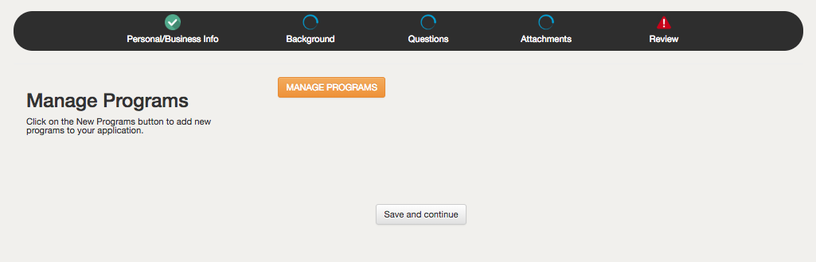
4.1 New window will open. Review this section for accuracy. Now, you can update tuition and fees. If your program hours do not require a substantive change, you may update.  DO NOT ADD PROGRAMS  Upon completion of your updates, select Save Changes. | 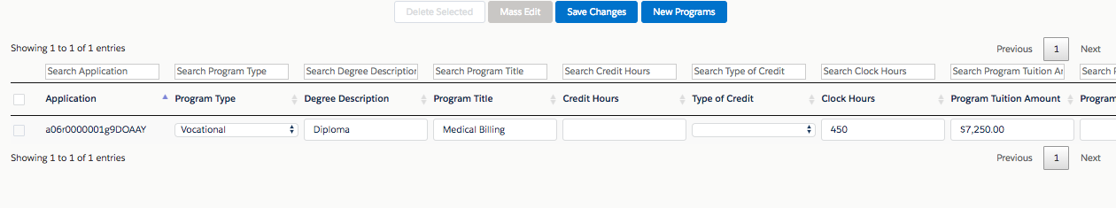
4.2 – After saving your work, close tab to return to portal. | 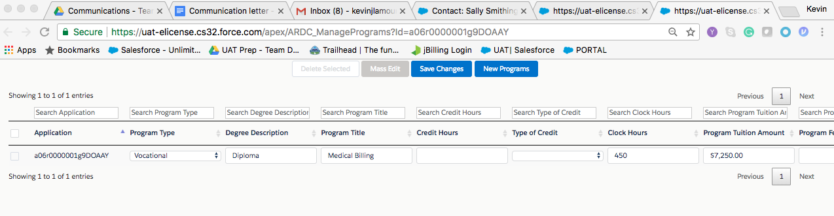
4.3 – Save and continue | 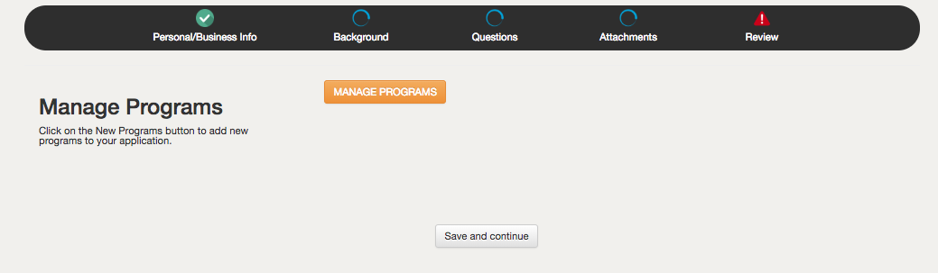
5.0 Answer ALL questions by selecting from the dropdown menu. | 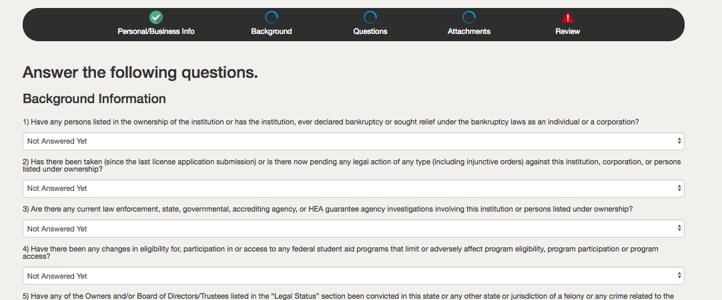
Application
6.0 Complete application questions. Please have your statistics ready for both Degree and Vocational programs. | 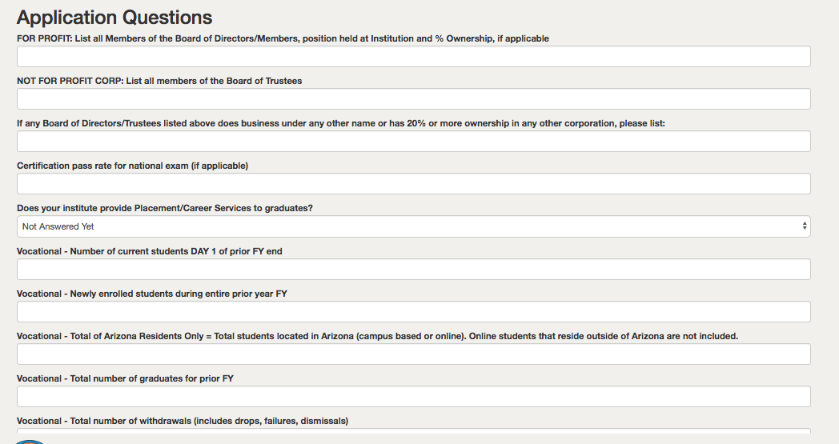
6.1 Vocational/Degree questions…  - Answer questions  - Total Arizona Only students = All students (residential or online) that reside in Arizona or are taking on-site classes in Arizona. Used for Student Tuition Recovery Fund (STRF).  Save and continue. | 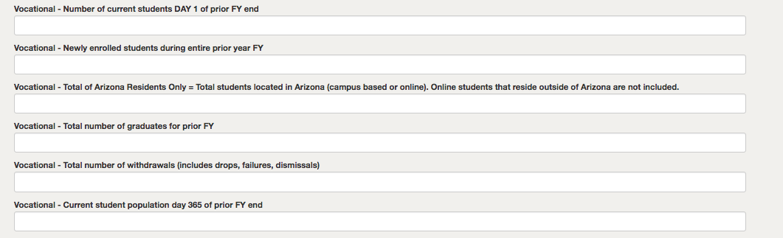
Attachments
7.0 – Carefully read documents required for upload. Documents include…  - Student Enrollment Contract/Agreement  - Catalog  - List of Faculty and Administrative Staff  - Proof of Lability Insurance  - Financial Position  - Institutional Payment Plans  - Resumes of Instructor/Faculty  - Owner’s Affidavit | 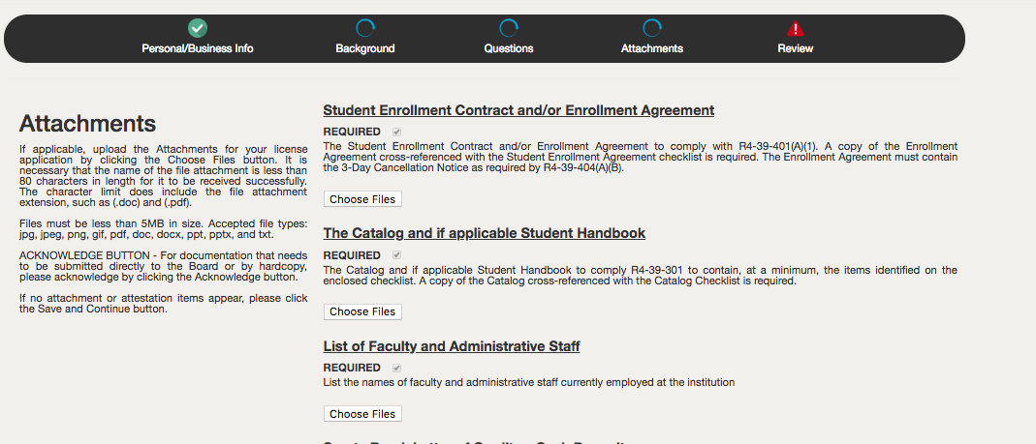
7.1 Upload Documents  - Click Choose Files  - Select the file on your computer you want to upload. | 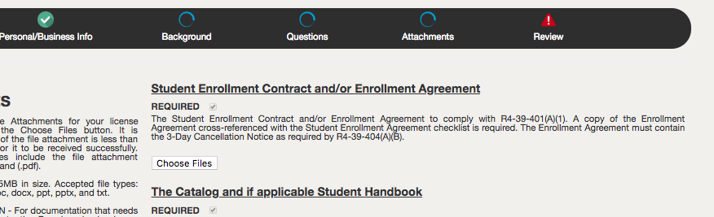
7.2 Save and Continue | 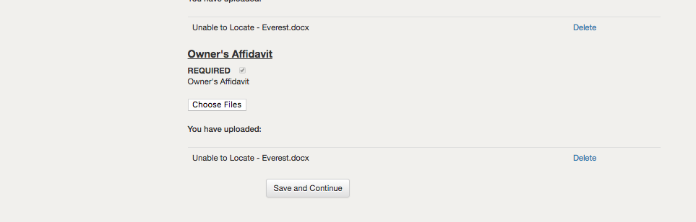
7.3 Review and sign  - If all items have been complete, you will receive 3 green bars.  - Review affidavit  - Electronically sign application. | 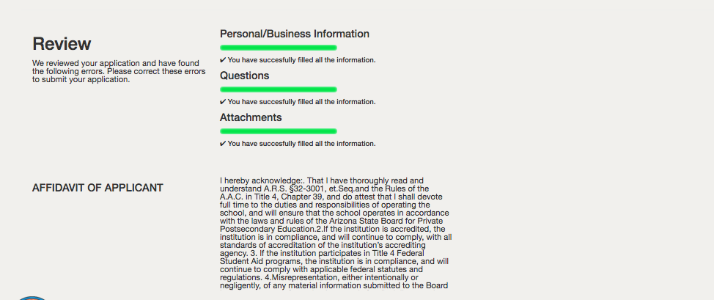
- Important, once you click Submit – No additional changes can be made via the portal. You may select “Save and continue later” prior to final submit if additional changes need to be made. If everything is complete, click Submit.
Pay Fees
8.0 Review fees and select continue | 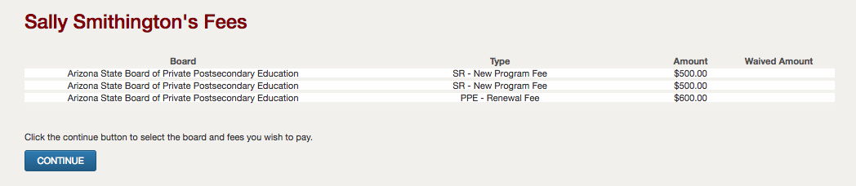
8.1 Select correct board… Arizona State Board of Private Postsecondary Education.  Click Continue | 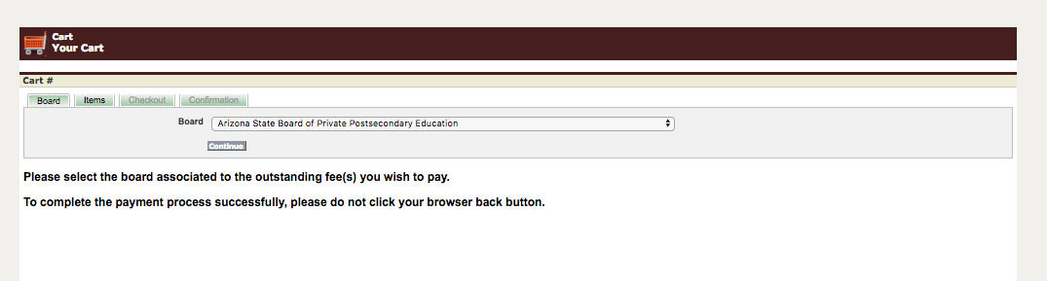
8.2 Click correct fee, select refresh fee and then continue. | 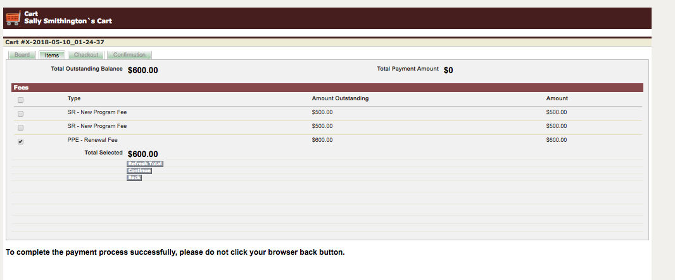
8.3 Select type of payment (Credit Card or Electronic Check) - $3 service fee for Credit Card payment will be added.  For  Select Process Payment | 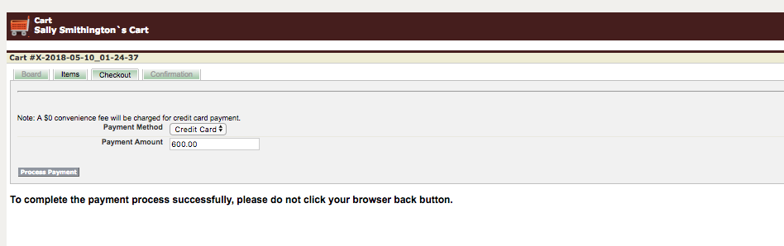
8.4 – Complete payment information.  Receipt will be emailed to you.  Select “authorize” to complete transaction. | 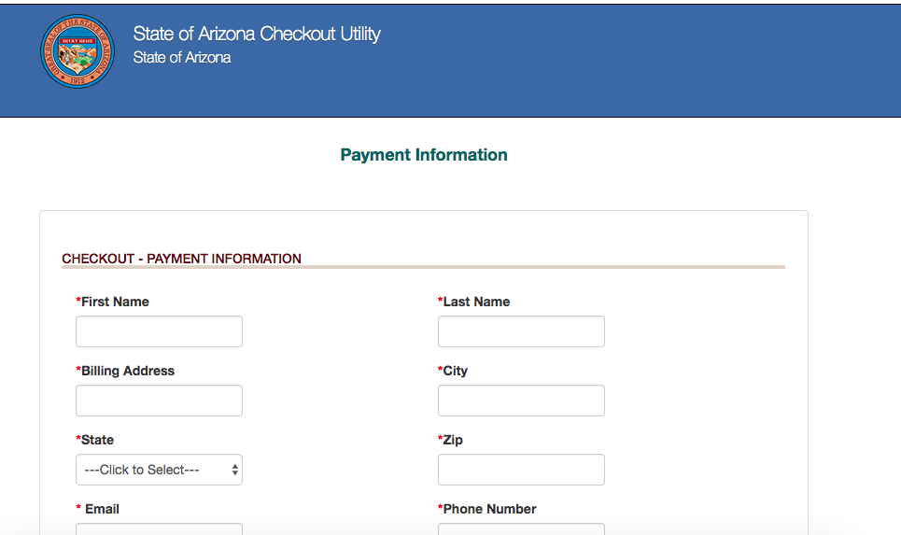
8.5 – Receipt will be available to reivew or print. Click back to return to portal screen. | 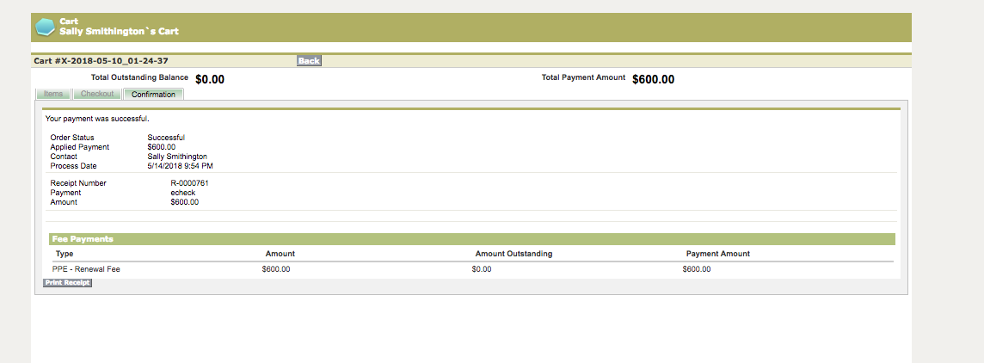
Renewal Process Complete

