Arizona State Board for Private Postsecondary Education
NON-DISCRIMINATION POLICY

In recognition of its legal and moral obligations, the Arizona State Board for Private Postsecondary Education hereby commits itself to a policy of non-discrimination as follows:

- The Arizona State Board for Private Postsecondary Education shall not discriminate on the basis of race, color, national origin, religion, age, disability, genetic information, sex, pregnancy, military or veteran status, or any other status protected by federal law, state law, or regulation. Equal Opportunity applies to such employment practices as hiring, upgrading, demotion, transfer, recruitment, advertising, layoff, termination, rates of pay or other forms of compensation, selection for training, job assignments, accessibility, working conditions, and special assignments.

- All Arizona State Board for Private Postsecondary Education management personnel shall actively support recruitment and career development programs to ensure equitable representation of individuals on a nondiscriminatory basis, in all job categories and pay grades.

- The Arizona State Board for Private Postsecondary Education shall not tolerate discrimination in the agency as it creates an intimidating, degenerating, hostile, and offensive working environment. Each employee has an affirmative duty to maintain a workplace free of harassment, intimidation, discrimination. Arizona State Board for Private Postsecondary Education prohibits retaliation against any individual who reports discrimination or harassment or participates in an investigation of such reports.

- The Arizona State Board for Private Postsecondary Education will post the Non-Discrimination Policy throughout departmental facilities, and communicate electronically either by email and/or by posting on employee-facing websites/intranet pages, as appropriate.

- All written bid announcements, requests for proposals, employment announcements, requests for applications, program brochures, literature, and general solicitations shall include the phrase:

“AN EQUAL EMPLOYMENT OPPORTUNITY AGENCY”

The Arizona State Board for Private Postsecondary Education is committed to ensuring that all its employees can work in an environment free from harassment, discrimination, and retaliation.

As Executive Director of the Arizona State Board for Private Postsecondary Education, I am committed to the principles of Equal Employment Opportunity. To ensure the dissemination and implementation of the Equal Opportunity Plan throughout all levels of the Department, Kevin LaMountain shall serve as the Equal Opportunity Administrator for the Arizona State Board for Private Postsecondary Education, 602-542-5716, kevin.lamountain@azppse.gov.

This policy is accessible to employees at (website address and physical location/s within agency).

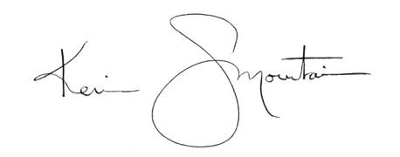
______________________________________
Kevin J. LaMountain, Executive Director Date: January 5, 2023

Any employee who has any questions or concerns about this policy should talk with the (Agency Contact) at (telephone number) or the Governor's Office of Equal Opportunity, http://eo.azgovernor.gov, 602-542-3711.

